The title must be Maximum Two Lines, Times New Roman 12pt, Bold Single Space With Each Initial Letter Capitalized:
(leave one blank line, two if the title contains only one line)
Authors names: Ichiro Tomonaga(underline the principal aruthor), Jiro Esaki, etc.:
Times 10pt, centered.
Affiliation, address and e-mail address of the principal author: Times 10pt, centered.

Authors are requested to submit a one-page abstract of their contributions including title, name(s) of author(s) and affiliation(s) in Word for Windows file. Abstracts should be written in English. Abstracts longer than two pages will not be accepted. Do not use page numbers in the word processor. It is composed of two columns. Each column must be 8 cm width. The spacing between the columns must be 1 cm. The left and right margins must be 2 cm, the top and the bottom margins must be 2.5 cm.
The manuscript is to be typed using "Times New Roman" (or equivalent). The size for the title is 12pt. All the other parts of the text are typed using Times New Roman 10pt. The title is centered and boldface. The spacing between the lines is one (single spacing). The title must be centered between the margins. Leave one blank line between the centered title and the centered names of the authors. The name of the principal author, who will present the paper at the Conference, should be underlined. Follow immediately below, and on a separate line, with affiliations. Leave two blank lines before starting the text.
The equations are numbered and typed in the appropriate place in the text. The size of the character is similar to that used for the text (Times New Roman 10pt). The following equation is an example created by Word Equation Editor.

(

The figures are reduced to fit within the margins of each column. Symbols and legends are large enough to be readable. Tables and figures are numbered in the order they appear in the text.

Table 1. Typical values for ω, and γ at a few temperatures in a rhombohedral phase.
T (K) | ω (GHz) | γ (GHz)
420.0 | 15.3 | 7.8
370.0 | 18.4 | 5.0
320.0 | 20.2 | 2.1

The list of references must place at the end of the text if needed. The references must be numbered in order of text citation and abbreviated.

To submit the Abstract, please upload the files of abstract in word and PDF format by logging-in to your “My Page” and clicking on the “Abstract”.
The file name should include the name of the principal author. The deadline for abstracts is Jan. 9, 2016.
All the abstracts will be reviewed and the criterion of rejection will be a lack of originality. Accepted abstracts will be published in the USB memory stick of abstracts at the beginning of the conference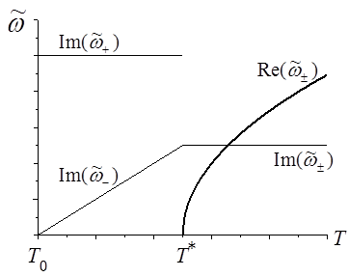
Fig. 1: Temperature dependences of the real and imaginary part of the soft mode frequency.....
(Figure caption should be attached to each figure.)

References
[1] V. N. Novikov, N. V. Surovtsev, and S. Kojima, J. Chem. Phys. 115, 5278 (2001).
[2] R. Blinc, Advanced Ferroelectricity (Oxford University Press, Kettering, 2011).
[3]

....

